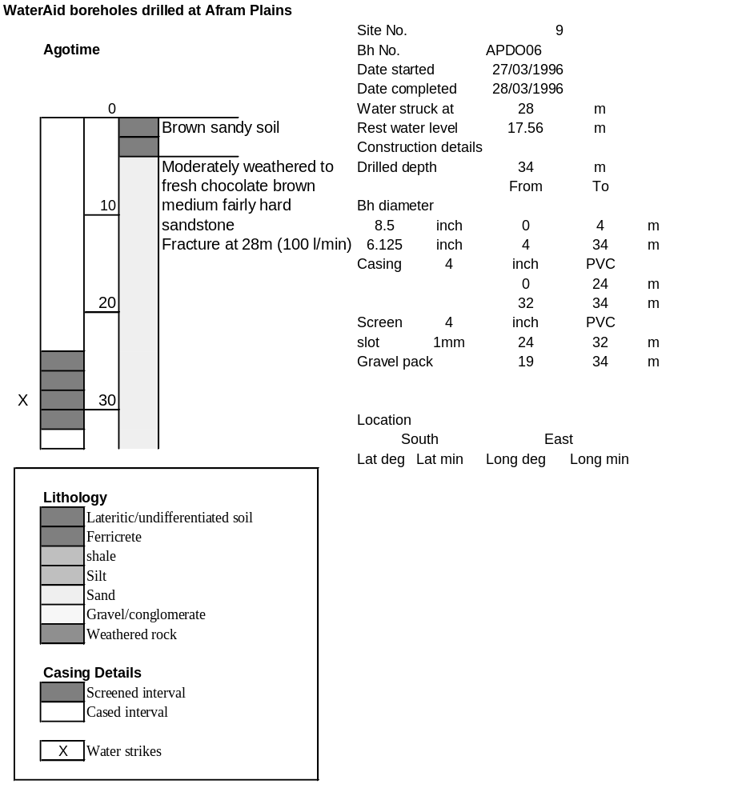

Ghana | Test pumping
Borehole No. |  | APDO6
Hole No |  | 9
Village |  | Agotime
Date |  | 16/04/1996
Point above GL |  | 0.5 | m
Pump depth |  | 23 | m
SWL |  | 18.06 | m
Start Time |  | 07:55
Drawdown test |  |  |  |  | Recovery test
time | pwl (m) | Q l/min | dd | sc | Time | wl (m) | s' | t/t'
0.00 | 18.06 | 75.00 | 0.00 |  | 0.00 | 20.78 | 2.72
1.00 | 19.34 | 75.00 | 1.28 | 58.59 | 1.00 | 19.66 | 1.60 | 181.00
2.00 | 19.46 | 75.00 | 1.40 | 53.57 | 2.00 | 19.52 | 1.46 | 91.00
3.00 | 19.53 | 75.00 | 1.47 | 51.02 | 3.00 | 19.39 | 1.33 | 61.00
4.00 | 19.54 | 75.00 | 1.48 | 50.68 | 4.00 | 19.30 | 1.24 | 46.00
5.00 | 19.70 | 75.00 | 1.64 | 45.73 | 5.00 | 19.23 | 1.17 | 37.00
6.00 | 19.76 | 75.00 | 1.70 | 44.12 | 6.00 | 19.17 | 1.11 | 31.00
7.00 | 19.80 | 75.00 | 1.74 | 43.10 | 7.00 | 19.11 | 1.05 | 26.71
8.00 | 19.83 | 75.00 | 1.77 | 42.37 | 8.00 | 19.07 | 1.01 | 23.50
9.00 | 19.87 | 75.00 | 1.81 | 41.44 | 9.00 | 19.02 | 0.96 | 21.00
10.00 | 19.89 | 75.00 | 1.83 | 40.98 | 10.00 | 18.99 | 0.93 | 19.00
11.00 | 19.91 | 75.00 | 1.85 | 40.54 | 12.00 | 18.85 | 0.79 | 16.00
12.00 | 19.93 | 75.00 | 1.87 | 40.11 | 14.00 | 18.75 | 0.69 | 13.86
13.00 | 19.96 | 75.00 | 1.90 | 39.47 | 16.00 | 18.76 | 0.70 | 12.25
14.00 | 19.97 | 75.00 | 1.91 | 39.27 | 18.00 | 18.74 | 0.68 | 11.00
15.00 | 20.01 | 75.00 | 1.95 | 38.46 | 20.00 | 18.73 | 0.67 | 10.00
16.00 | 20.02 | 75.00 | 1.96 | 38.27 | 22.00 | 18.72 | 0.66 | 9.18
17.00 | 20.03 | 75.00 | 1.97 | 38.07 | 24.00 | 18.69 | 0.63 | 8.50
18.00 | 20.04 | 75.00 | 1.98 | 37.88 | 26.00 | 18.67 | 0.61 | 7.92
19.00 | 20.06 | 75.00 | 2.00 | 37.50 | 28.00 | 18.65 | 0.59 | 7.43
20.00 | 20.09 | 75.00 | 2.03 | 36.95 | 30.00 | 18.63 | 0.57 | 7.00
22.00 | 20.09 | 75.00 | 2.03 | 36.95 | 35.00 | 18.58 | 0.52 | 6.14
24.00 | 20.26 | 75.00 | 2.20 | 34.09 | 40.00 | 18.55 | 0.49 | 5.50
26.00 | 20.32 | 75.00 | 2.26 | 33.19 | 45.00 | 18.52 | 0.46 | 5.00
28.00 | 20.33 | 75.00 | 2.27 | 33.04 | 50.00 | 18.49 | 0.43 | 4.60
30.00 | 20.42 | 75.00 | 2.36 | 31.78 | 60.00 | 18.45 | 0.39 | 4.00
35.00 | 20.50 | 75.00 | 2.44 | 30.74 | 70.00 | 18.42 | 0.36 | 3.57
40.00 | 20.49 | 75.00 | 2.43 | 30.86 | 80.00 | 18.40 | 0.34 | 3.25
45.00 | 20.53 | 75.00 | 2.47 | 30.36 | 90.00 | 18.38 | 0.32 | 3.00
50.00 | 20.56 | 75.00 | 2.50 | 30.00 | 100.00 | 18.37 | 0.31 | 2.80
55.00 | 20.57 | 75.00 | 2.51 | 29.88 | 110.00 | 18.36 | 0.30 | 2.64
60.00 | 20.61 | 75.00 | 2.55 | 29.41 | 120.00 | 18.36 | 0.30 | 2.50
70.00 | 20.64 | 75.00 | 2.58 | 29.07
80.00 | 20.67 | 75.00 | 2.61 | 28.74
90.00 | 20.70 | 75.00 | 2.64 | 28.41
100.00 | 20.72 | 75.00 | 2.66 | 28.20
110.00 | 20.74 | 75.00 | 2.68 | 27.99
120.00 | 20.74 | 75.00 | 2.68 | 27.99
130.00 | 20.74 | 75.00 | 2.68 | 27.99
140.00 | 20.76 | 75.00 | 2.70 | 27.78
160.00 | 20.77 | 75.00 | 2.71 | 27.68
180.00 | 20.78 | 75.00 | 2.72 | 27.57
